**Algorithmic Complexity and Big-O Notation**

The graph below compares the running times of various algorithms.

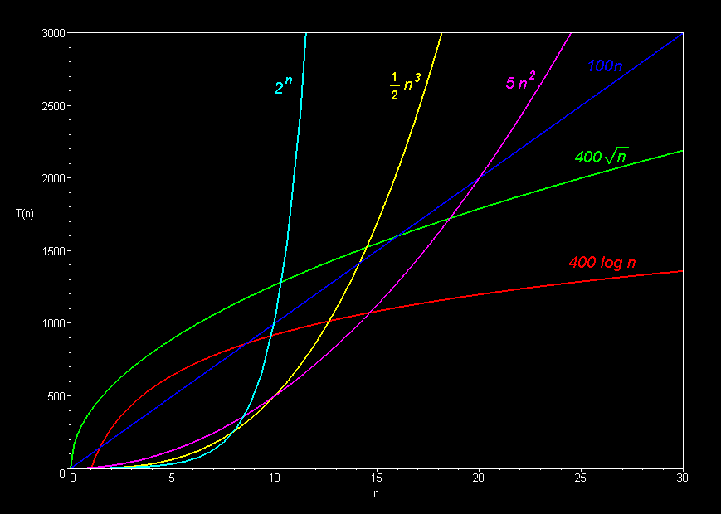Linear: O(*n*)

Quadratic: O(*n2*)

Cubic: O(*n3*)

Logarithmic: O(log *n*)

Exponential: O(2*n*)

Square root: O(sqrt *n*)

Comparison of algorithms in terms of the maximum problem size they can handle:   
 

|  |  |  |  |
| --- | --- | --- | --- |
| Algorithm Complexity | Running time T(n)  (measured in seconds on an Apple Delicious computer) | Maximum problem size given 1000 seconds on an Apple Delicious | Computer Speed x 10  Maximum problem size given 1000 seconds on a Power Delicious (or 10,000 seconds on a classic Delicious) |
| O(n) | 100n | n = 10 | n = 100 *(x 10 increase)* |
| O(n2) | 5n2 | n = 14 | n = 45 *(x 3)* |
| O(n3) | **½** n3 | n = 12 | n = 27 *(x 2)* |
| O(2n) | 2n | n = 10 | n = 13 *(x 1.3)* |
| O(sqrt n) | 400 sqrt(n) | n = 6 | n = 625 *(x 100)* |
| O(log n) | 400 log(n) | n = 12 | n = 72 billion *(x 6 billion)* |

MORAL: Cheaper, faster computers mean bigger problems to solve.   
Bigger problems to solve mean efficiency is *more* important.

The basic shape of a polynomial function is determined by the highest valued exponent in the polynomial (called the *order* of the polynomial).

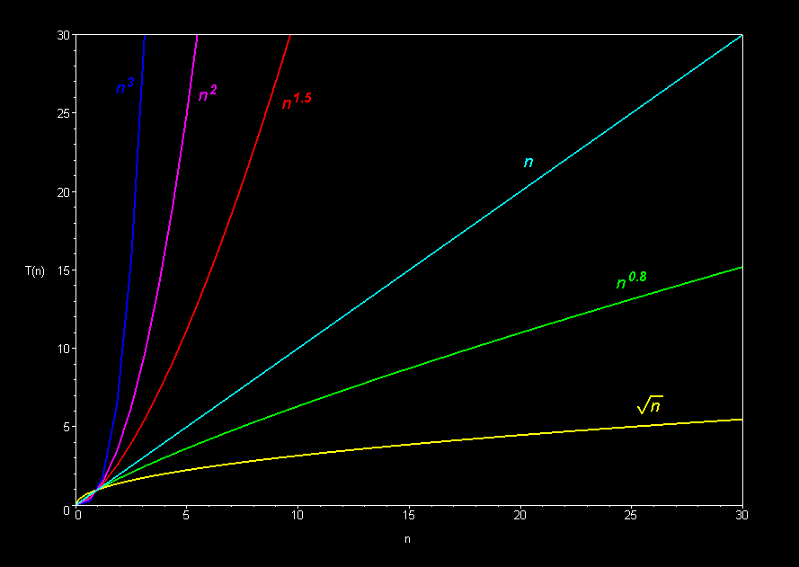

Multiplicative constants do not affect the fundamental shape of a curve.  Only the steepness of the curve is affected.

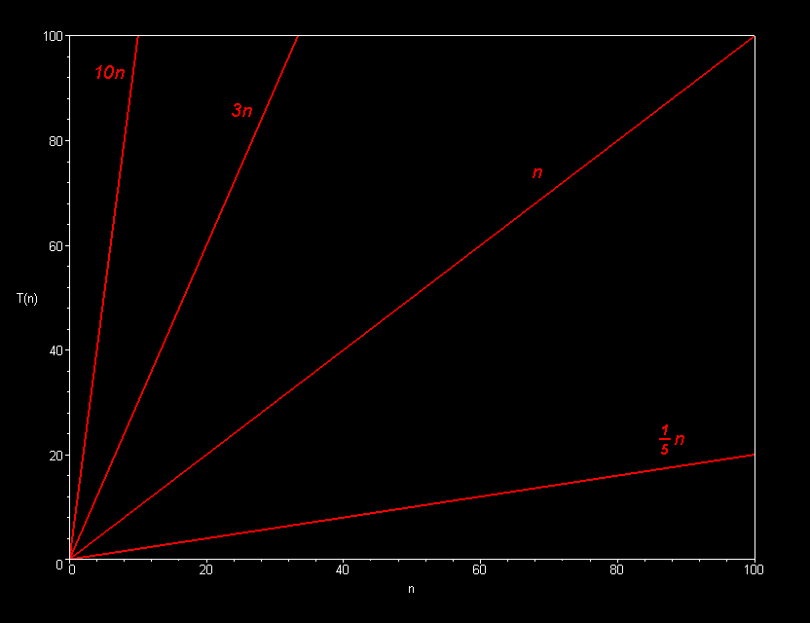

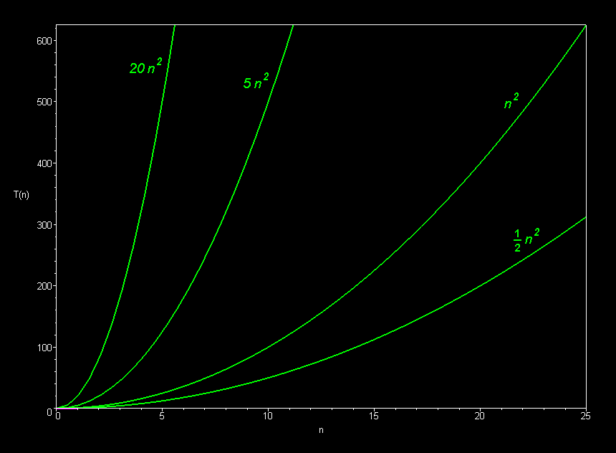**Linear Family**

**Quadratic Family**

**Cubic Family**

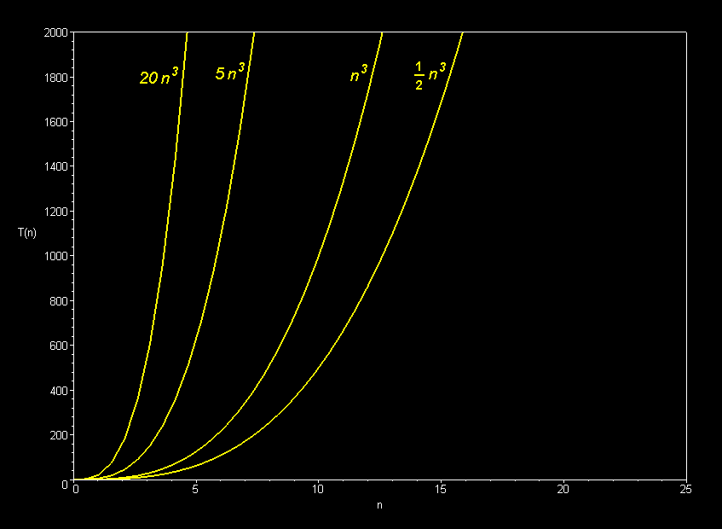

Only the *dominant terms* of a polynomial matter in the long run.  Lower-order terms fade to insignificance as the problem size increases.

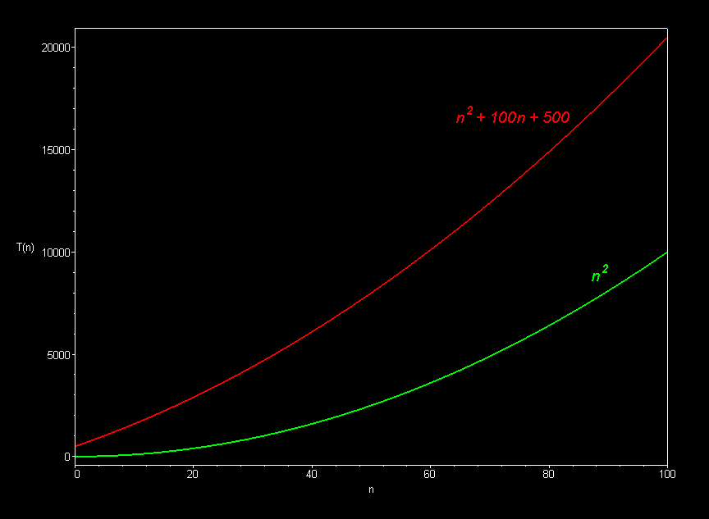  
 

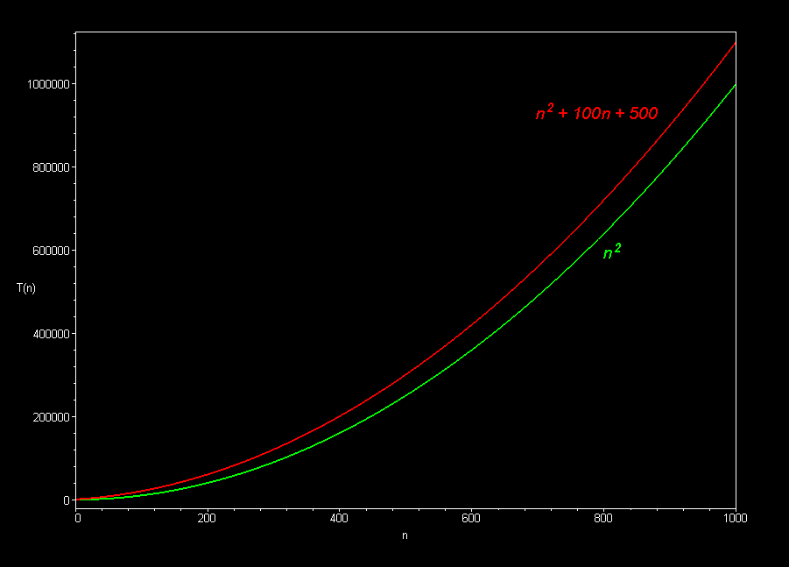

    
    
 

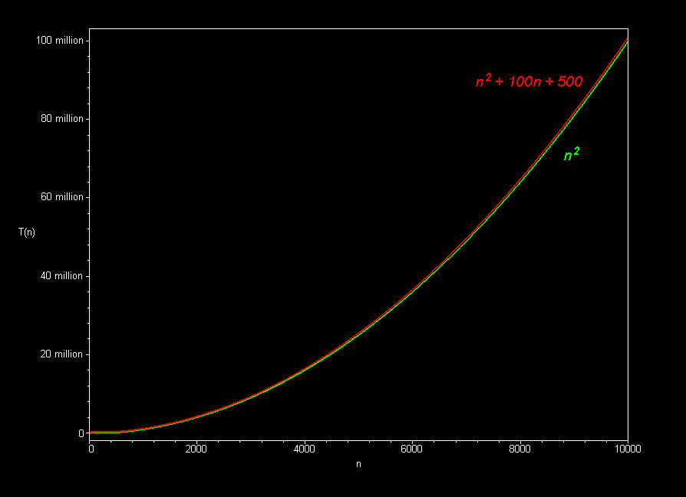

The best sorting algorithms (such as mergesort) run in O(*n* log *n*) time.  Slower ones (such as bubble sort, selection sort, and insertion sort), take O(*n2*) time.

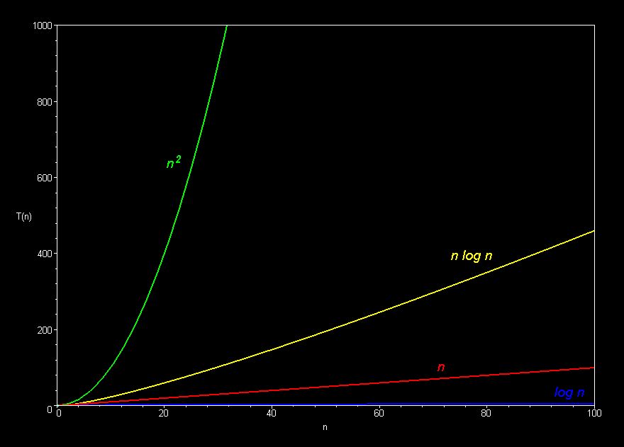Polynomial curves will always overtake logarithmic curves eventually, when the problem size gets big enough, regardless of the multiplicative constants involved.

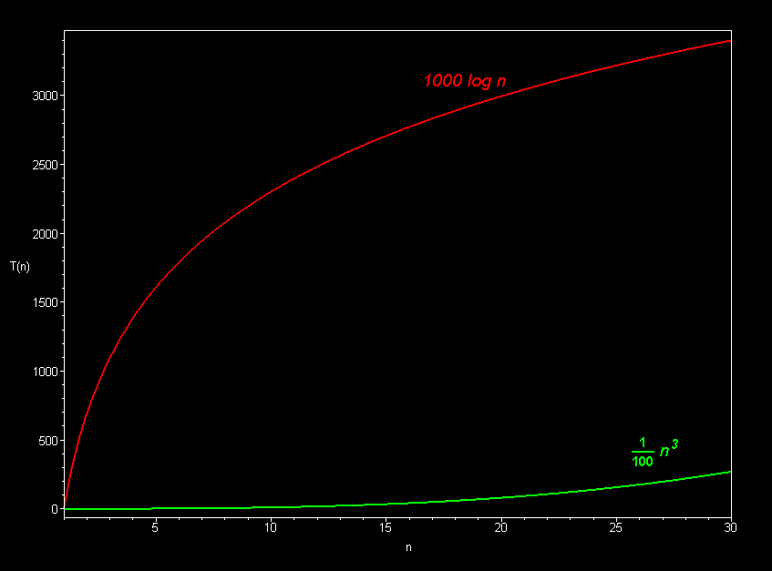  
    
    
 

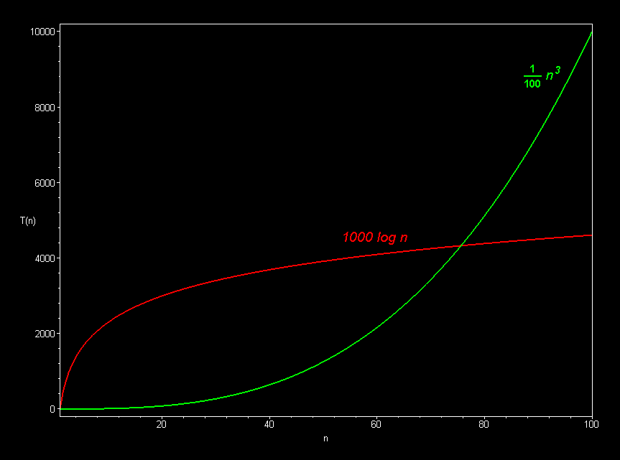  
The superiority of the O(log *n*) Fermat prime test over the O(sqrt *n*) prime test becomes clear for really big integers.

